Game Design Document Try-Guys

|  |  |  |  |
| --- | --- | --- | --- |
| Document and Project Revision List | | | |
| Version | Author | Date | Comments |
| 0.1 | Thomas Riches | 24/09/2019 | Draft document |
| 0.2 | Tembani Mdaya  Andrew Scott | 03/02/2020 | Added some text and images. |
| 1.0 | Tembani Mdaya  Andrew Scott  Thomas Riches | 05/02/2020 | Added initial map design and finished Game testing overview. |

Table of Contents

Introduction 2

Refrences 2

Platform and Software 2

Game Specification 2

Game Concept 2

Story/setting 4

Game Features 5

objective 5

Graphics 5

Gameplay 5

overview 5

Controls 5

Map Design 5

Game Testing 7

Team 7

# Introduction

The game we are going to create is a first-person platformer with a Semi-Linier Structure. The game is set in a post-apocalyptic wasteland where they find themselves stranded in a gorge. The player must make use of free-running abilities and a grappling look

The game will incorporate elements similar to games like Mirror’s Edge and Titanfall 2.

## Refrences

<https://github.com/Tri-Guys>

# Platform and Software

The game will be developed for use with either a keyboard or a controller on Windows, but could be made to work for mobiles and tablets. The game will be developed in the Unity game engine using a 2.5D environment as the team has more experience with Unity than the Unreal Engine.

# Game Specification

## Game Concept

The game is inspired by a few gameplay concepts found in titles released in the last decade and a half.

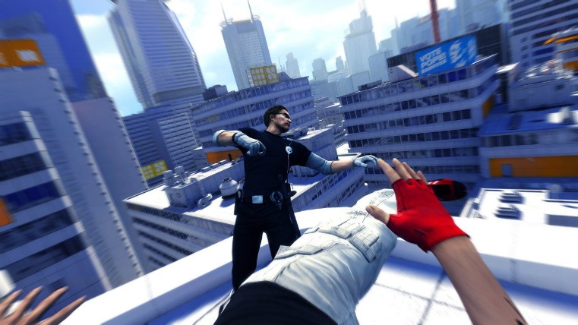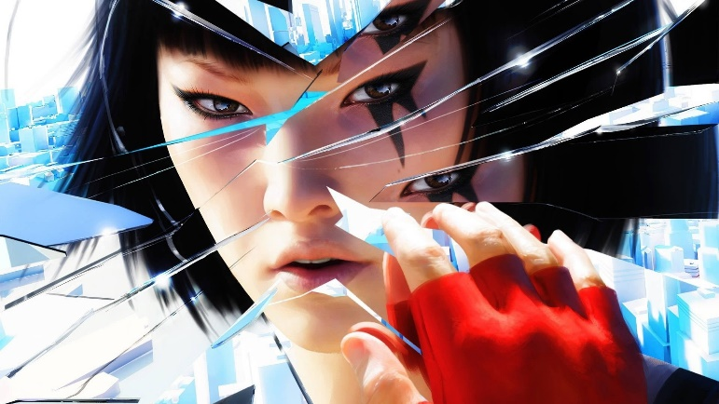

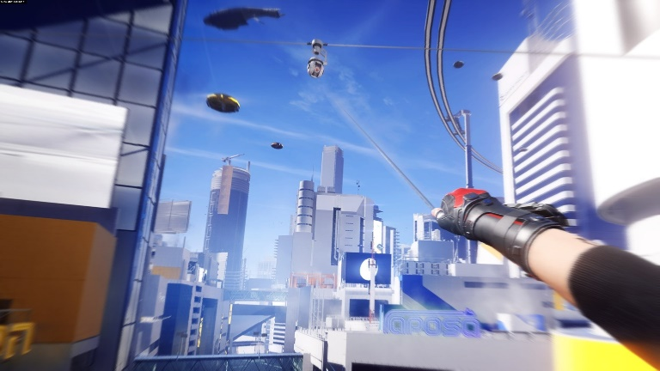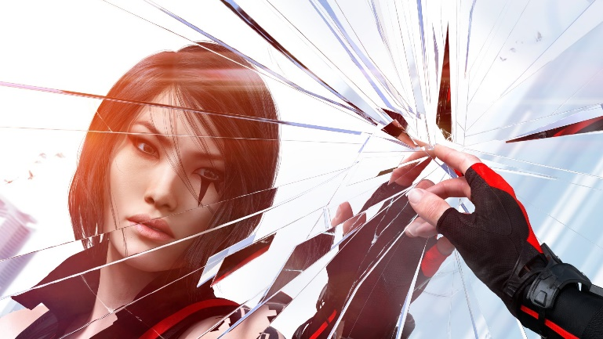

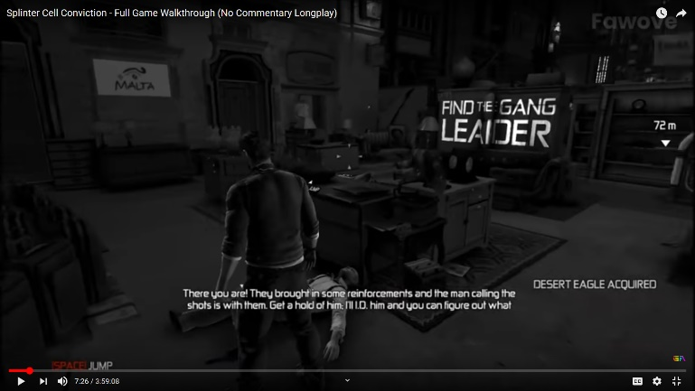In 2016 a re-sequel called **Mirror’s Edge: Catalyst** was released, resetting the story and locking most of Faith’s abilities behind a skill tree. With enough effort the player can unlock and gain back key parts of Faith’s repertoire such as safety rolls for making safer landings. Additionally, she can gain access to a piece of equipment similar to a grappling hook, allowing her to zip herself up onto certain high ledges or grab onto nearby drones to cross large gaps.

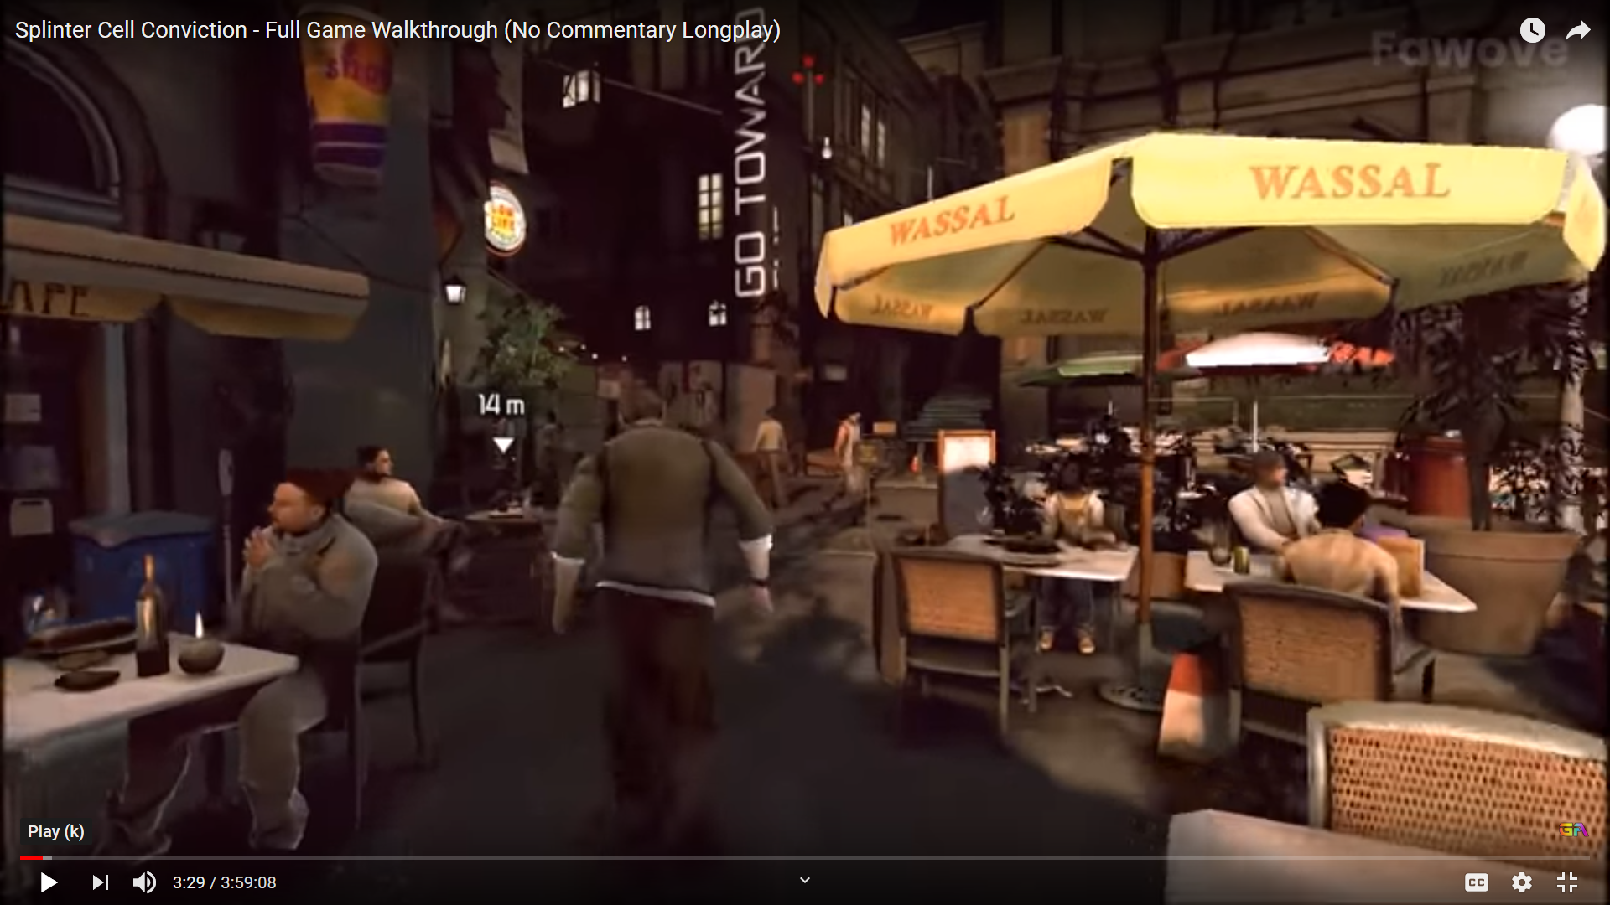

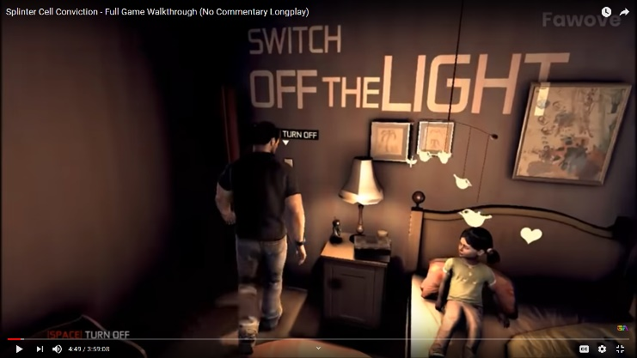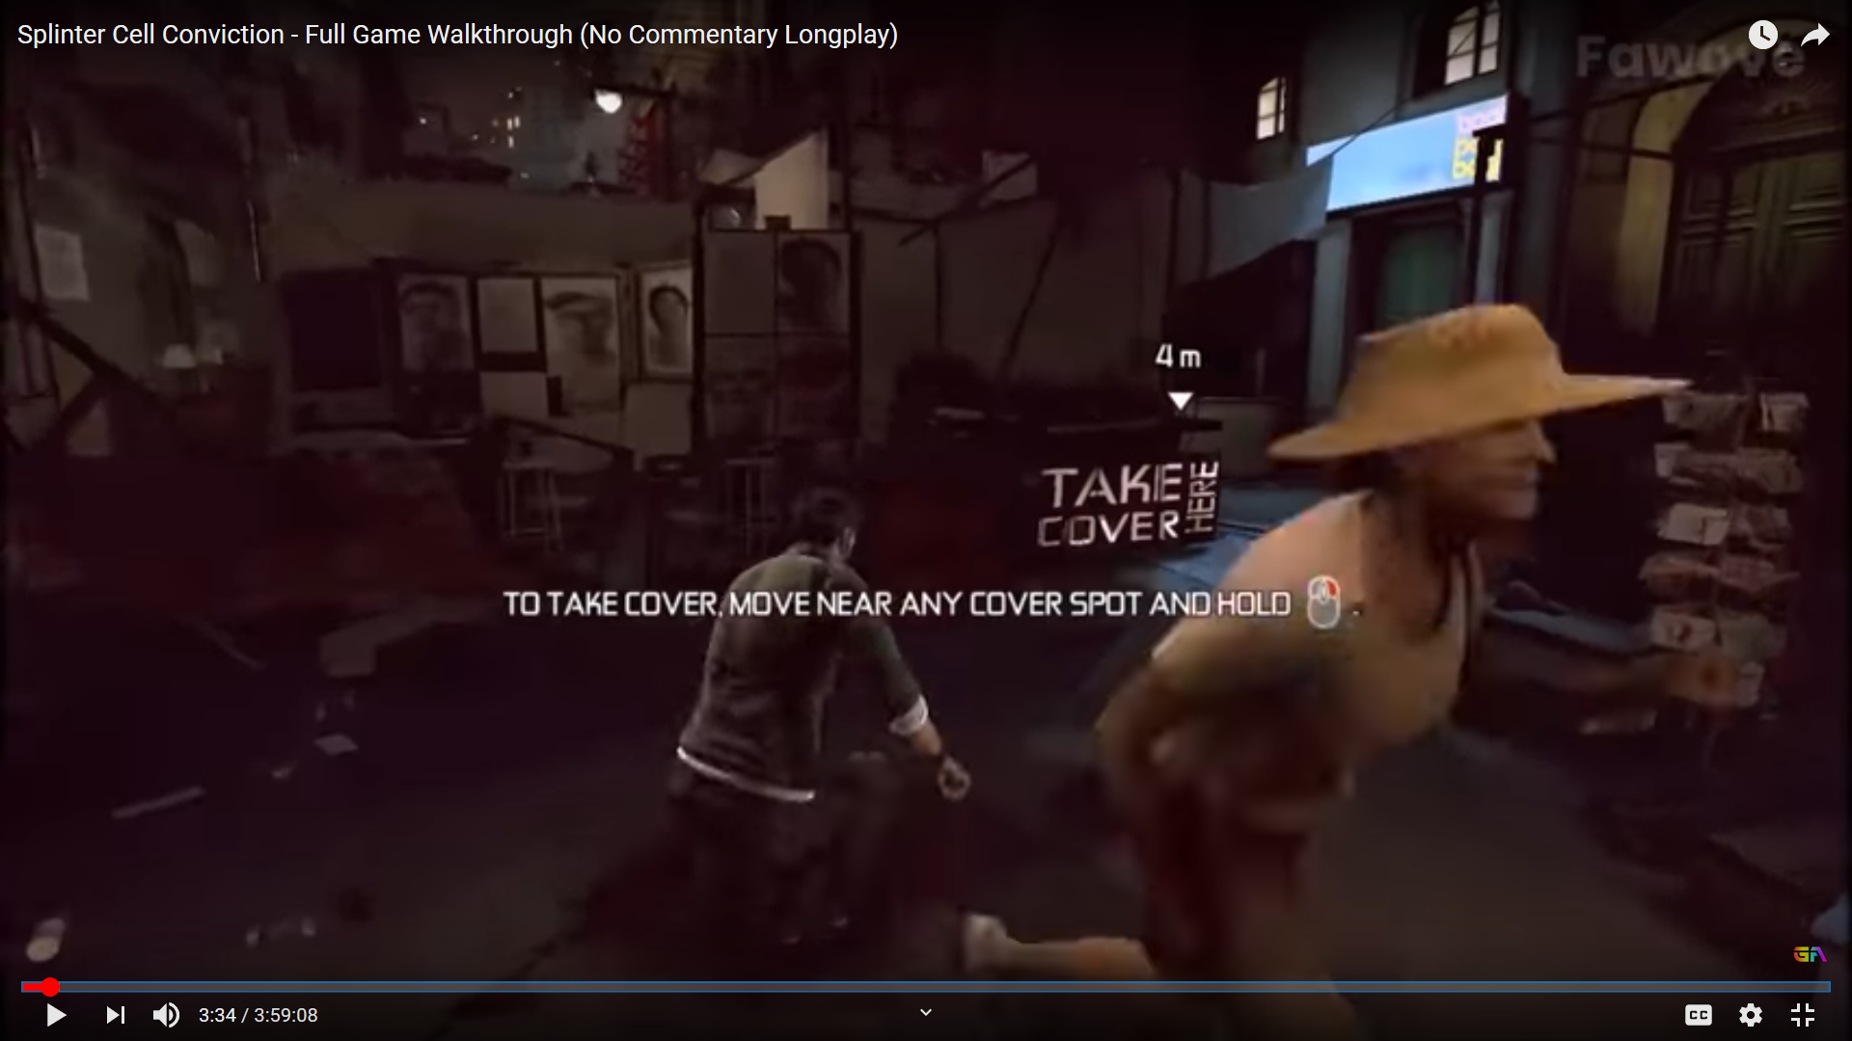

In Ubisoft's **Splinter Cell Conviction**, a new visual hint system was introduced as part of the instalment's new art design. At the beginning of every major story event and after each major cutscene the player's camera would return to its default position behind series protagonist Sam Fisher, a rogue Third Echelon agent, before drawing Sam's current objective on a surface in the player's field of view.

This new system takes the place of the franchise's previous method of displaying the objective through the heads-up-display by drawing the works. The method used to display the words is more than an environmental effect: should Sam attempt to stand in front of the guide the words will be drawn on him as if standing in front of a projector. This same effect is also used at crucial points in the story, displaying flashback moments on both the walls and key actors as if they're standing in front of a physical projector.

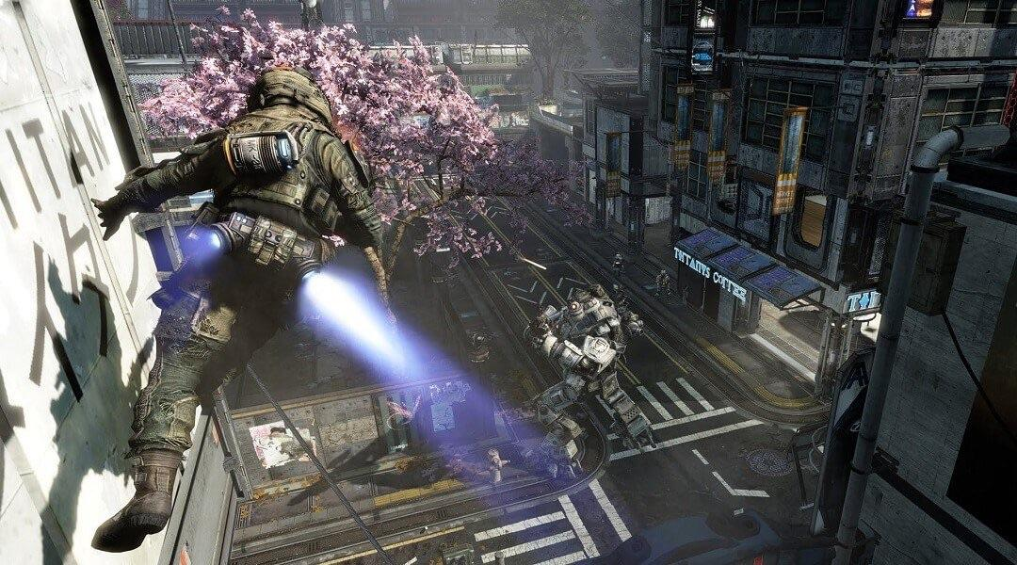

Respawn Entertainment's **Titanfall** was a 2014 multiplayer-only title which pitted two teams of highly agile players dubbed Pilots against one another, in a map packed with cannon fodder AI infantry set up for slaughter. The key game-mode Attrition is a spin on the traditional Team Deathmatch found in shooters: players choose a loadout for their Pilot.

Titanfall 2 carries over the multiplayer and core gameplay of its predecessor while adding many new features. The tight free running movement, which combines wall running with a double jump, has been augmented with an always-available slide for crouching while sprinting. In the revised multiplayer and the brand-new single-player, the player can equip the ability to launch a flexible temporary grappling hook. Simply attaching hook onto a surface will pull the player towards it but holding a direction will allow you to swing with momentum.

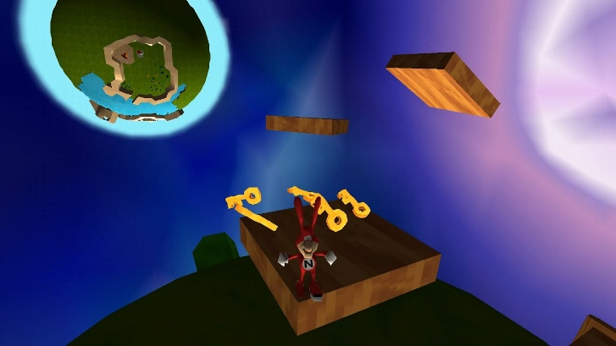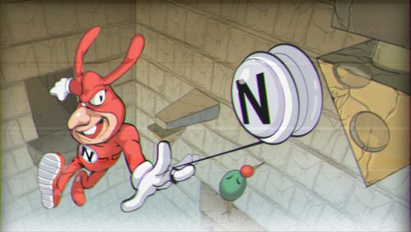

Similarly, the fan game Yo Noid! 2 which features the retired Dominos mascot The Noid also features a grappling hook mechanic in the form of The Noid's yo-yo. There are key perches, poles and containers The Noid can grab onto with the yo-yo to pull, open and even swing from. Additionally, The Noid himself can wall run for a short distance and wall jump, allowing similar chaining of mobility moves and increased agility.

## Story/setting

You are a downed pilot. In the event of your aircraft, a contingency in the form of training and mastery of a grappling hook was put in place. You must make use of your training and equipment to scale desolate buildings and clear bottomless caverns to escape the gorge.

Welcome to the Wastelands.

## Game Features

The player will be armed with enhanced mobility compared to other games, coming out of the gate with a double jump and the ability to run and jump off walls.

In place of a weapon the player will have access to a grappling hook utility. The hook works within a set distance, but once it catches onto a desired surface it will not disengage without the player’s input.  
  
The Hook will attach to distinct black obsidian rocks that are attached to some of the walls of the buildings in the game.

## objective

The player has one objective: escape. Every area has a solution.

## Graphics

The game will be from a first-person perspective, to help immerse the player and allow them to judge depth better.

# Gameplay

## overview

The gameplay will involve the player utilising their abilities to make sense of several cave-themed climbing frames, tasking them with completing them and rewarding them with harder climbing puzzles.

## Controls

The player will use the WASD keys to move around the play space, the space bar is used to jump, the mouse is used to look and the left mouse button will be used to shoot and disengage your hook.

## Map Design

Starting off at a canyon, in between long narrow path to introduce movement controls.   
The controls will be shown displayed on the walls but in a way that fits in with the world (no signposts).  
Afterwards, the space will get bigger to allow more freedom in movement/practising what you learned while also demonstrating new movement controls. This part of the Level will be Linear as to allow the player a chance to get to grips with the controls.

Afterwards, the player will go to the next area but the ground/area will crumble and fall and time will slow down to show the player the grapple hook and where to use it.  
(to help subvert expectations making the level a little more memorable)

And then the Level opens up, this will have the player be put into a big area that will have a visible end goal but no instructions on how to get there allowing for a non-linier experience, giving the player control of how to get to the end. This is to engage the player in using the knowledge they gained beforehand and do some thinking and experimenting with abilities.

The levels will have desert-esc colour pallet as it will be set in a desert canyon, this will include a range of warm reds yellows and oranges with some very dark reds marking objects that can be grappled to by the player. In addition, Green foliage will be placed in areas of importance to make them more visible as it stands out against the harsh background of a desert.

The lighting of the level will overall be bright with some areas of shade being put in contrast with the green foliage to further mark areas of interest, it could also be used as a subtle way to guide the player to their objective in the level, (i.e. having a beam of light cut through a dark area to show the area the player has to get to.) 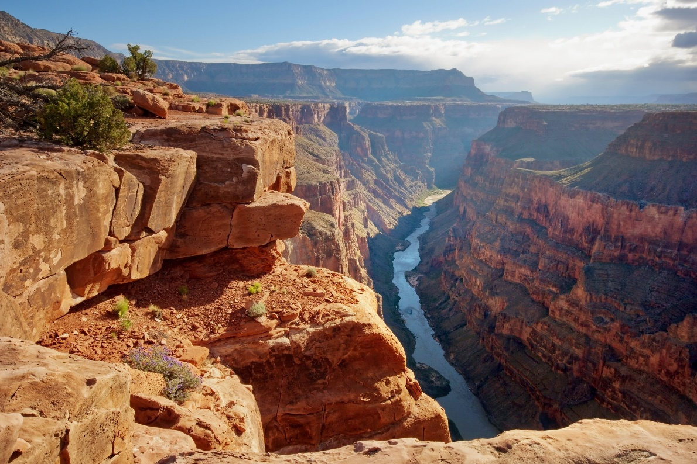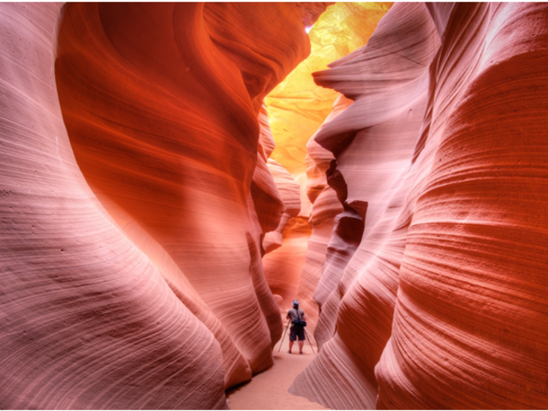

# Game Testing



While making the game we plan on using White-Box testing to make sure that the main mechanics of the game work properly, the game runs smoothly and remove any other bug’s we find on the way. We will then move to Black-Box testing to get a broad testing range to find any other bus that may have been missed and get an idea of how the game feels, if it flows well, is engaging and looks good from other people. To get results from the Black-Box testing we will ask people to take a small Survey to get an idea how the felt about the game.

Examples of questions we may ask are:

* Did you find the game accessible to your skill level?
* How well did the Game teach you how to play?
* Did you find the level designed confusing at all?
* How well did you feel the game play flow together?

# Team

Andrew Scott – Programmer, coordinator

Tembani Mdaya – Lead artist, composer

Thomas Riches – Programmer, designer